
MINI PROJECT PHASE I - 2025-2026

MINI PROJECT TITLE

ONLINE CALCULATOR WEBSITE

Submitted by
S.Vijay
DATE

Under the Supervision of
PROF. Mrs.A.JENIFA

PPG INSTITUTE OF TECHNOLOGY
COIMBATORE

1. | MINI Project Title: ONLINE CALCULATOR WEBSITE
2. | Sector: Web Development
3.  4. | Introduction:  With the rise of web-based tools, users expect lightweight, accessible, and visually appealing utilities. A calculator is an ideal example to demonstrate these principles.  The Online Calculator project provides a simple interface with buttons for digits and arithmetic operators. JavaScript captures button clicks, performs calculations, and displays results in real-time.  This project showcases key programming concepts such as:  DOM (Document Object Model) manipulation  Event-driven programming  CSS styling and layout design  Client-side computation  The final result is a working calculator that operates entirely in the browser — no backend, no external libraries.  Problem Statement:  - In the modern digital world, performing quick and accurate arithmetic operations is essential for students, professionals, and daily users. While physical calculators are common, there is an increasing preference for online, portable, and easy-to-use calculators that work on any device without installation.  - Traditional calculators have limitations — they cannot be easily accessed on computers without external software, and they lack interactive design features. Hence, there is a need for a web-based calculator that is lightweight, visually appealing, and capable of performing accurate calculations.  - The Online Calculator project solves this problem by developing a simple and efficient web tool using HTML, CSS, and JavaScript. It allows users to perform arithmetic operations instantly in their browsers.

7. | Objectives of the project:  1.To develop a fully functional online calculator using web technologies.  2. To apply HTML, CSS, and JavaScript in a single integrated project.  3. To demonstrate event-driven programming concepts in JavaScript.  4. To create an interactive and visually appealing user interface.  5. To perform real-time calculations using client-side scripting.  6. To enhance understanding of DOM manipulation and front-end logic.
8. | Methodology:  The development process of the Online Calculator follows a systematic approach using the Web Development Life Cycle (WDLC).  Methodology :  - System Design & Planning  - Structure Design:The calculator layout is built using HTML with a display screen and buttons for digits and operations.  - Visual Design:CSS is used to style the calculator — setting colors, button shapes, spacing, and responsive layout.  - Functional Design:JavaScript handles the logic — capturing button clicks, performing arithmetic operations, and displaying results instantly.  - Front end  - The Front-End of the calculator is what the user sees and interacts with.  - It is created using HTML, CSS, and JavaScript.  - HTML defines the layout (buttons, display area).  - CSS adds color, style, and design to make the interface attractive.  - JavaScript handles user actions like button clicks and calculations.  - The entire calculator runs in the browser, providing instant results.

- Backend
This project is a front-end–only application, so there is no traditional back-end
All operations are processed within the browser using JavaScript.
However, in future enhancements, a back-end (e.g., PHP, Node.js, or Python) can be added to:
  - Store previous calculations or user history.
  - Provide login and personalized settings.
  - Save user preferences (like themes or modes).
- Data Acquisition and Processing
  - The calculator collects input data directly from the user through button clicks

  - Each button press (numbers or operators) is captured by JavaScript event listeners.

  - The input is displayed on the calculator screen in real-time using an HTML <input> field.

  - When the user presses the “=” button, the calculator processes the input expression.

  - JavaScript reads the entered string (for example, 5+3*2) and evaluates it using arithmetic logic or built-in functions like eval().

  - The result is computed instantly in the browser without using any server or external data source.
- Testing and Validation
- The calculator was tested for all arithmetic operations (addition, subtraction, multiplication, division) to ensure accurate results.

- Input validation was implemented to handle errors like invalid syntax or division by zero, displaying an “Error” message when needed.

- The interface was tested across multiple browsers and devices, confirming smooth performance and responsive design.

- Final Deployment and Demonstration
- The Online Calculator was deployed locally using standard web browsers, running directly through the HTML file without needing external servers.

- During demonstration, all arithmetic operations and error-handling features were showcased, proving the calculator’s accuracy and responsiveness.

- The final version successfully displayed a clean user interface, smooth functionality, and instant result generation during live presentation.

7.Future Enhancement;
- Add scientific operations (sin, cos, tan, sqrt, log, etc.).

- Introduce history tracking of previous calculations.

- Implement dark/light themes for user preference.

- Integrate with voice recognition for input.

- Convert into a PWA (Progressive Web App) for offline use

8.Industry and Social Revilance:

- Demonstrates web development fundamentals used in software companies.

- Helps understand interactive application design for browsers.

- Can be integrated into larger systems (e.g., educational portals, online tools).

- Provides a free, accessible tool usable on any device.

- Encourages digital literacy and web learning among students.

- Reduces dependence on physical devices for basic computations

Sample HTML Code:
<!DOCTYPE html>
<html lang="en">
<head>
<meta charset="UTF-8">
<meta name="viewport" content="width=device-width, initial-scale=1.0">
<title>Online Calculator</title>
<link rel="stylesheet" href="style.css">
</head>
<body>
<div class="calculator">
<input type="text" id="display" disabled>
<div class="buttons">
<button onclick="clearDisplay()">C</button>
<button onclick="appendValue('7')">7</button>
<button onclick="appendValue('8')">8</button>
<button onclick="appendValue('9')">9</button>
<button onclick="appendValue('+')">+</button>
<button onclick="appendValue('4')">4</button>
<button onclick="appendValue('5')">5</button>
<button onclick="appendValue('6')">6</button>
<button onclick="appendValue('-')">-</button>
<button onclick="appendValue('1')">1</button>
<button onclick="appendValue('2')">2</button>
<button onclick="appendValue('3')">3</button>
<button onclick="appendValue('')"></button>
<button onclick="appendValue('0')">0</button>
<button onclick="appendValue('/')">/</button>
<button onclick="calculate()">=</button>
</div>
</div>
<script src="script.js"></script>
</body>
</html>

Sample CSS Code:
body {
background-color: #f4f4f4;
font-family: Arial, sans-serif;
display: flex;
justify-content: center;
align-items: center;
height: 100vh;
}

.calculator {
background: #222;
padding: 20px;
border-radius: 10px;
}

#display {
width: 100%;
height: 50px;
font-size: 22px;
text-align: right;
margin-bottom: 10px;
border: none;
border-radius: 5px;
padding-right: 10px;
}

button {
width: 60px;
height: 60px;
margin: 5px;
font-size: 18px;
border: none;
border-radius: 8px;
background-color: #4caf50;
color: white;
cursor: pointer;
}

button:hover {
background-color: #45a049;
}
Sample java script code:

let display = document.getElementById('display');

function appendValue(value) {
display.value += value;
}

function clearDisplay() {
display.value = '';
}

function calculate() {
try {
display.value = eval(display.value);
} catch {
display.value = 'Error';
}
}

Work Plan:

Phase Activity Description Duration (Weeks) Expected Outcome

1 Requirement Analysis & Design Planning ->Week 1 ->Layout and function plan completed
2 HTML Page Development->Week 2->Calculator structure completed
3 CSS Styling & UI Design->Week 3->Attractive and user-friendly interface
4 JavaScript Functionality->Week 4–5->All arithmetic operations functional
5 Testing & Debugging->Week 6->Fully working error-free system
6 Documentation & Demonstration->Week 7->Final report, presentation, and demo ready

Expected outcome:

- A fully functional, browser-based calculator.

- A clean and responsive user interface.

- Real-time calculations using JavaScript.

- Error-free input handling.

- Foundation for future upgrades (scientific calculator, memory functions, etc.).

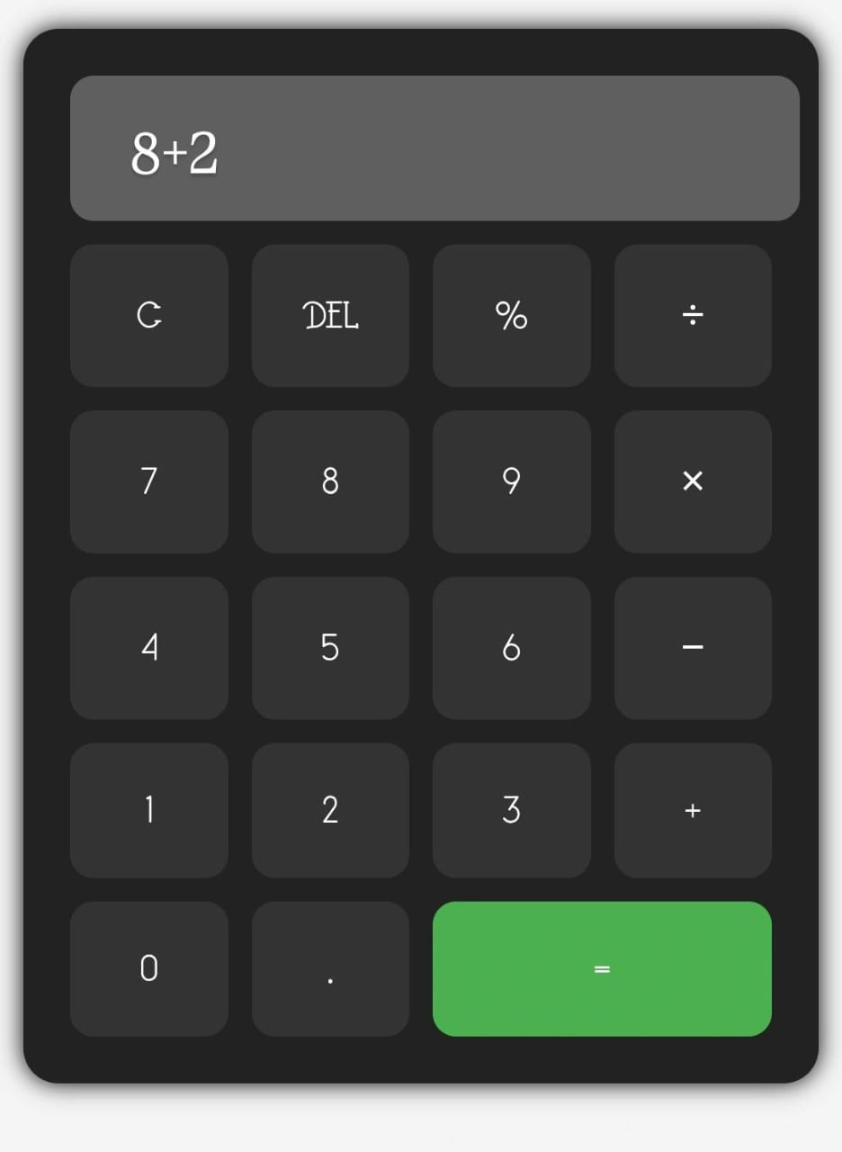

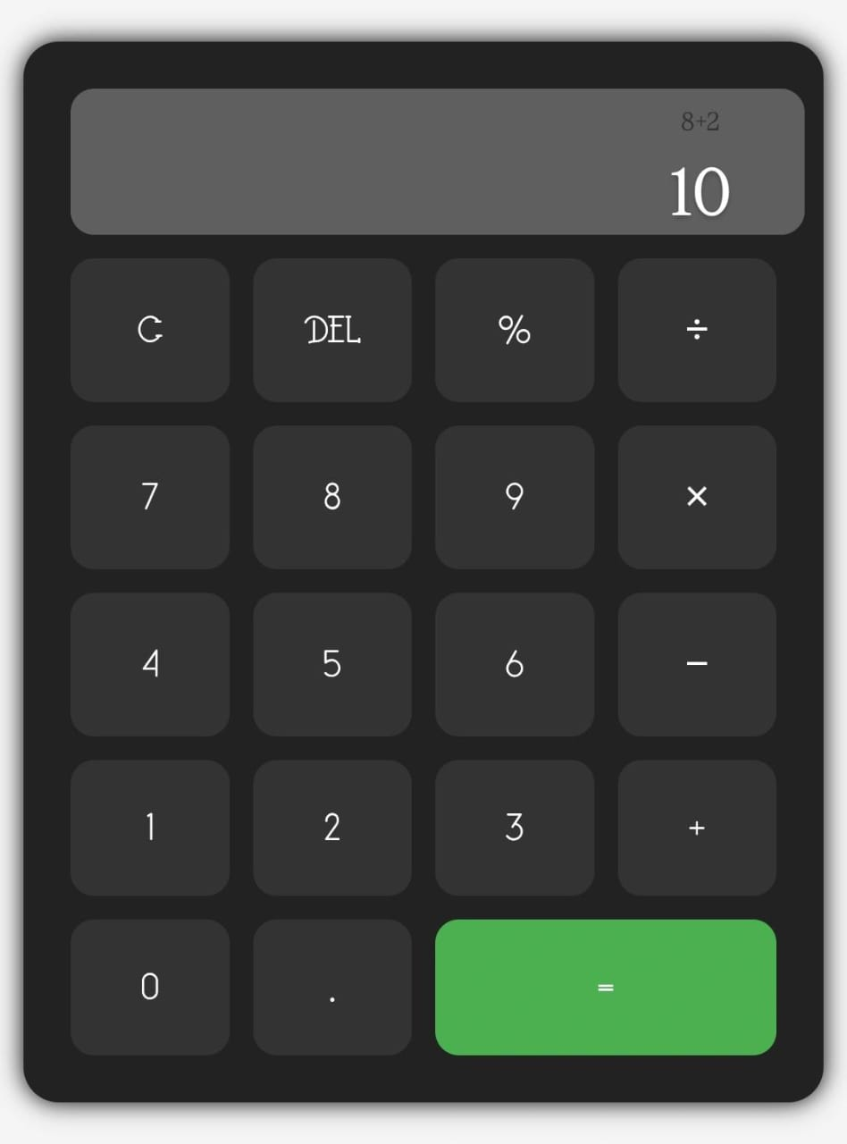

Conclusion:

The Online Calculator project successfully demonstrates the integration of HTML, CSS, and JavaScript to build a practical web-based tool. It highlights key web development skills such as event handling, UI design, and client-side scripting.

The calculator performs all basic operations accurately and efficiently. This project can serve as a foundation for more complex web applications and as an educational tool for understanding front-end programming.

DECLARATION
(From Project Students)

We, the project team hereby declare that the information provided in the enclosed project proposal (Title of the Project: ONLINE CALCULATOR, Branch: Computer Science and Engineering College: PPG Institute of Technology, Coimbatore – 641035) are true and correct to the best of our knowledge and belief.
We further declare that the proposed project work is original, not copied or purchased from any source. We are committed to carrying out the project independently, with appropriate guidance from our faculty and project guide, and by utilizing the facilities provided by our institution. We pledge to maintain academic integrity, avoid plagiarism, and work sincerely and diligently to execute and complete the project as proposed.
Name of the students with Register No. Signature with date
  - . S.VIJAY[712523104066]

Name & Signature of project Guide Name & Signature of HOD (with Seal)

